This manual outlines the functions and installation process as well as how to use the Android application Plants Matter, to assist the user. The Plants Matter app functions as a gardening assistant, designed to keep track of plants in a garden to help organise information and remind the user when their plants need to be watered. It should be noted that this manual covers the app while it is in an unfinished state and features that are in progress of development may be missing and have been labelled as such.

Warning: This application does not support IOS devices and is only available on Android OS.

Table of Contents

Installation Process…………………………………………………………………………………………………………………Page 2

Features………………………………………………………………………………………………………………………………….Page 5

How to Use………………………………………………………………………………………………………………………….…Page 6

Installation Process

This process outlines all actions needed to download Plants Matter

You will require a PC or laptop, an Android phone and a cable to connect your phone to your computer

(Your displays may differ from those shown depending on phone or computer model)

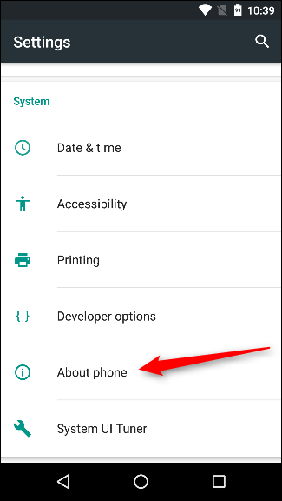**Part 1. Prepare your phone by enabling USB debugging**

Step 1. Go to phone settings and locate then select “About phone”

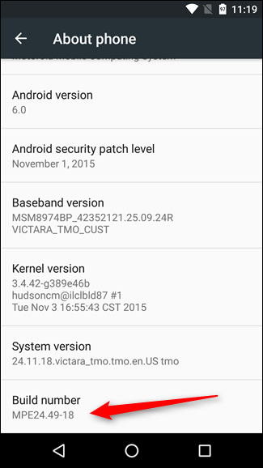

Step 2. Locate where it says build number and tap it 7 times to enable developer mode. You will be notified while tapping and when you are in developer mode.

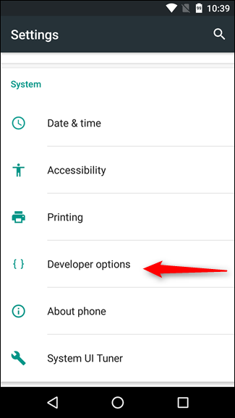

Step 3. Go back to the settings menu and locate and select “Developer settings” which should have now appeared

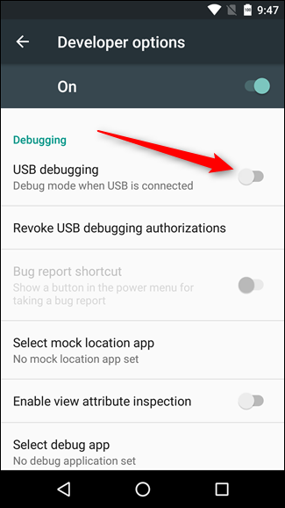

Step 4. Within developer options, tap the USB debugging slider and select “OK” on the following prompt. Your phone should now be able to use USB debugging to connect to a computer.

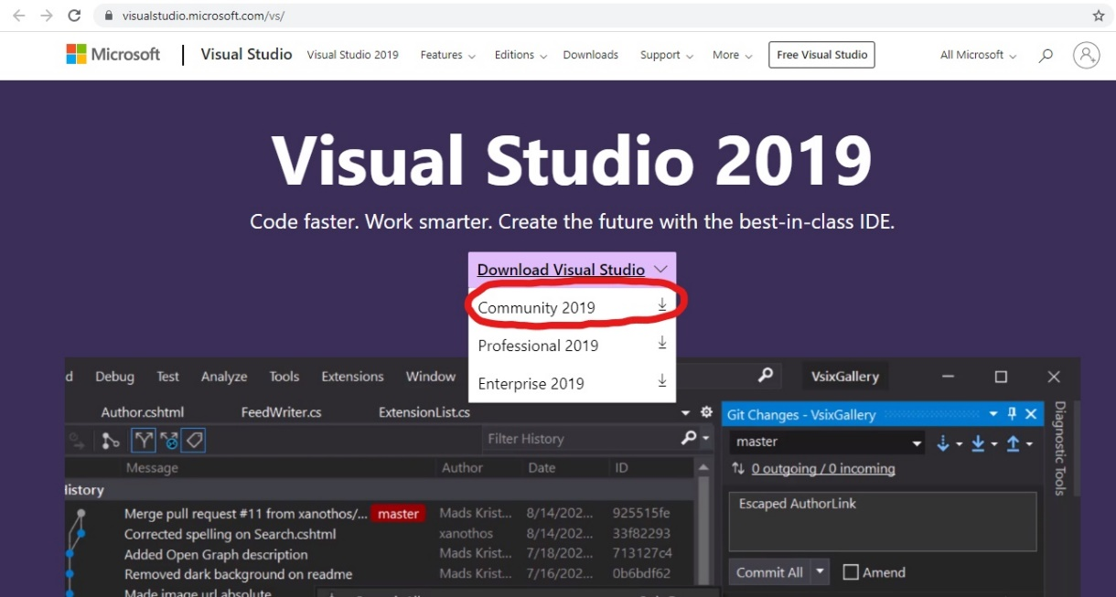**Part 2. Prepare your computer by installing visual studio with C# and Xamarin Forms**

Step 1. Download visual studio using the community 2019 option on the visual studio website.

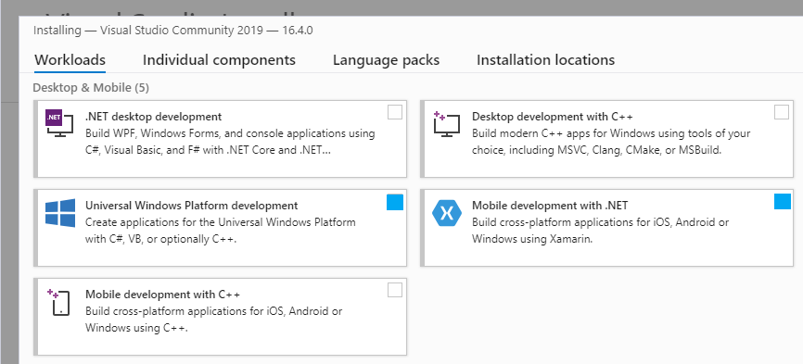

Step 2. During the download process, select the Universal Windows Platform development and Mobile development with .NET packs to install

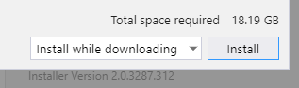

Step 3. Make sure you have the available disk space and select install. Once installed launch visual studio.

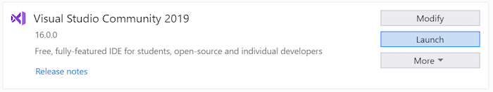

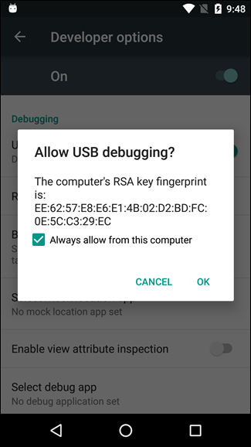**Part 3. Loading and launching Plants Matter**

Step 1. Plug your phone into your laptop or PC using a cable, upon doing so you will receive this prompt that you need to press “OK” for.

Step 2. Acquire a copy of the Plants Matter files and launch it in visual studio.



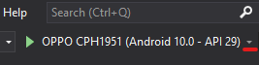

Step 3. In the top area of your visual studio developer space select the drop-down arrow next to the green play button and select your phone.

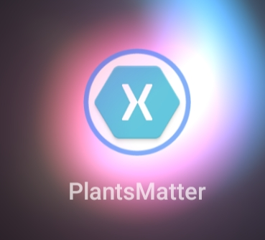

Step 4. Press the green play button to the left of your phone name, which should launch debug mode and install the app onto your phone. Plants Matter Should now officially be installed and appear on your device.

Features

This section displays the features that Plants Matter provides to help you garden

(This area is limited as many features are not currently implemented)

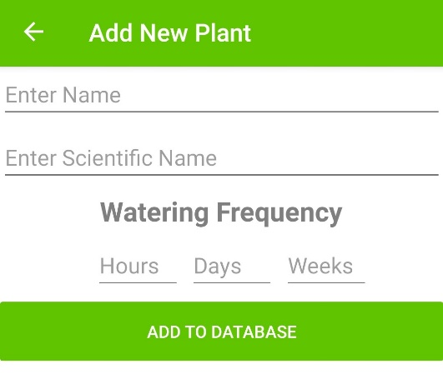**Feature 1: Add plants to the database**

You can add your own plants from your garden into the app. You can enter their name, scientific name and how frequently they need to be watered by hour, day and week. Additionally, you can even add emojis to the names if you so wish.

**Feature 2: See a list of your plants displayed**

Your added plants can be displayed in a list, as long as you need it to be. This allows you to easily see all your plants information in one convenient location.

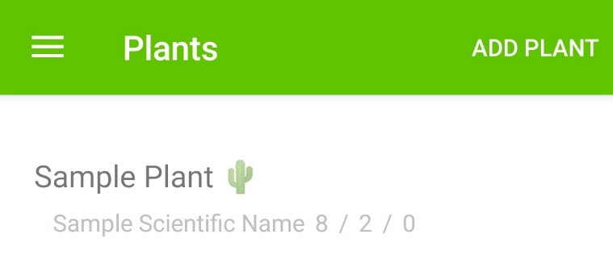

**Feature 3: Be notified of when your plants need to be watered.**

**(This feature is not currently implemented)**



When implemented, you will be notified when one or more of your plants needs to be watered, calculated from their watering frequency.

How to Use

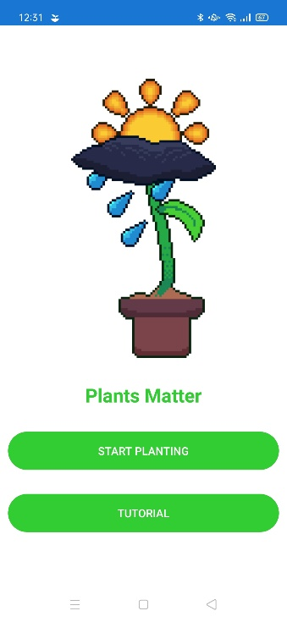This section outlines how to access and use the features of the Plants Matter app

Upon start up of Plants Matter, the log in page will greet you. Providing the options of tutorial or start planting, if you ever need to revise how to use the app then you may select tutorial. Otherwise select start planting

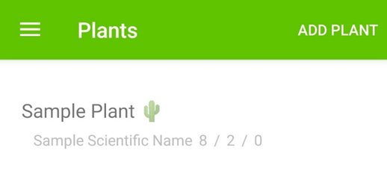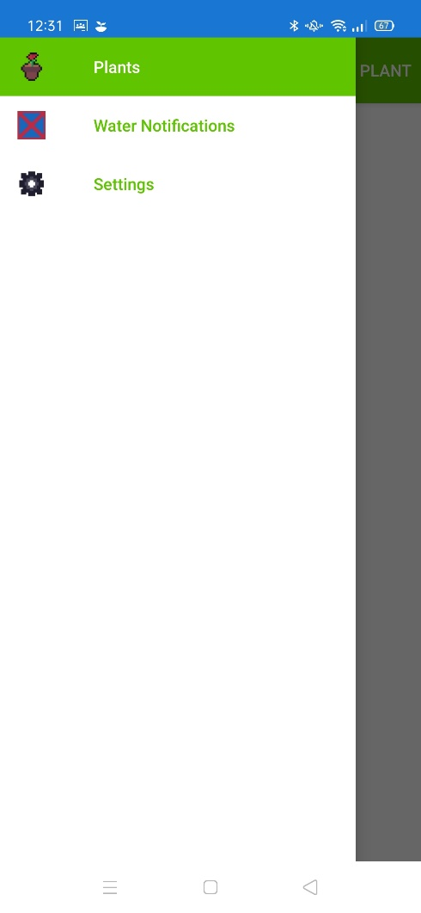

Upon selecting “Start planting”, you will be brought to the plant list page. Here all your plants within the database will be displayed with their scientific names and watering times.

If you select add plant in the top right then you are able to add new plants to the database which will appear in the list. If you wish to leave the add plant screen, press the back arrow in the top left. See features for more details.

If you select the three horizontal lines in the top left, it will bring out the flyout menu. This menu will bring you to the page that you select from it.